Reg ID - GO_STP_6834

Day 18:

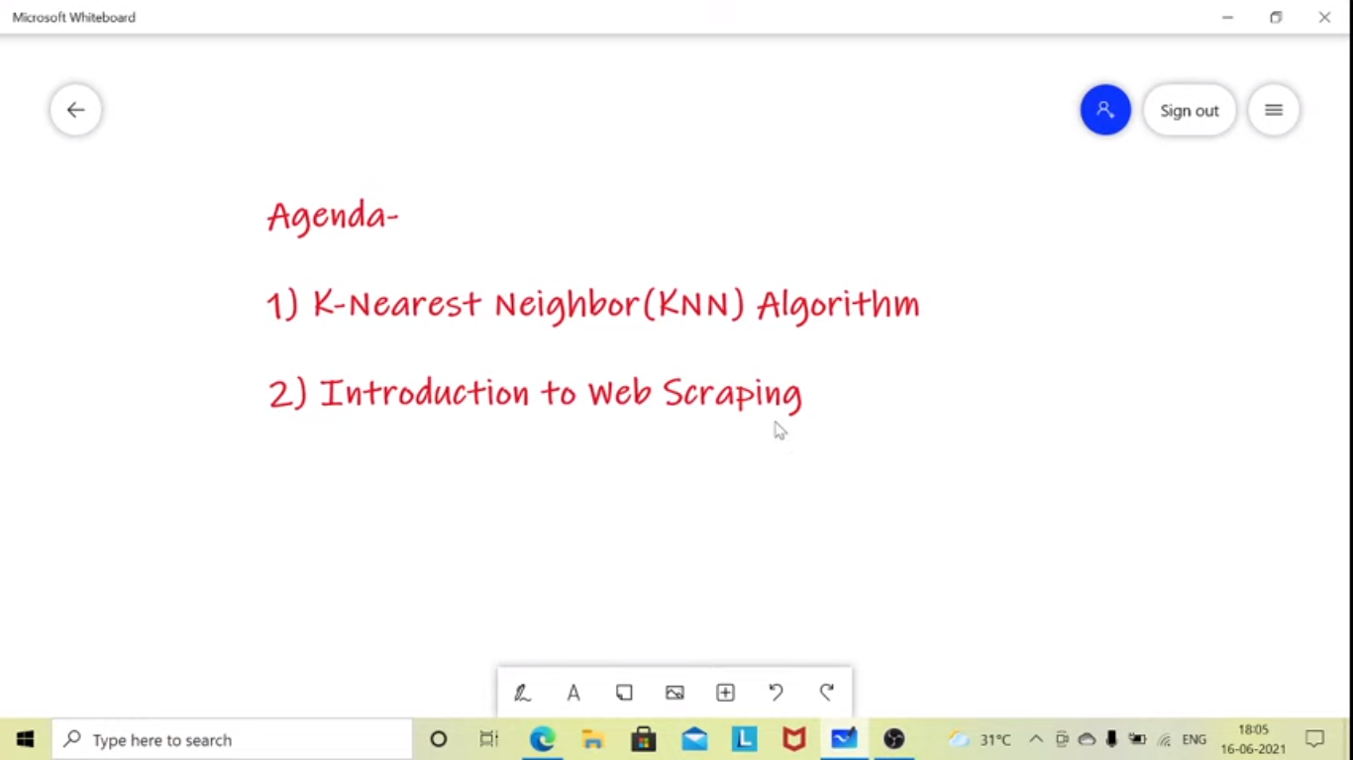

A supervised ml, can be used for the regression or classification

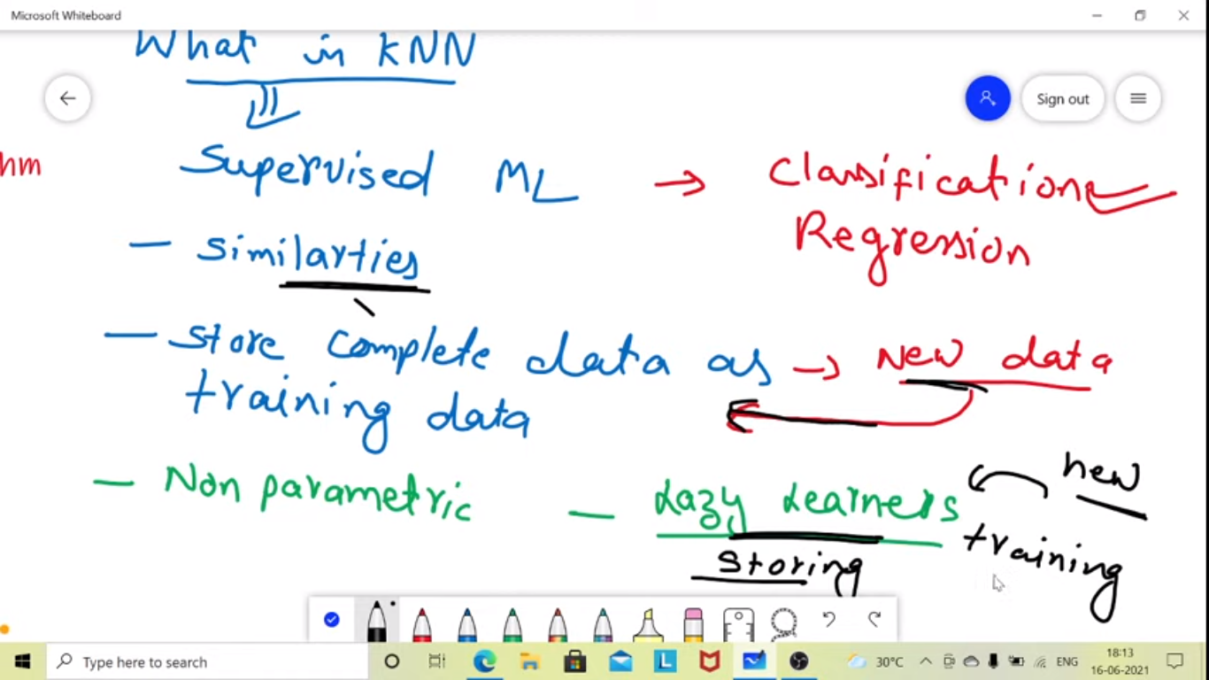

It store the complete data and when we give new data it comapres and find similarities.

Lazy Learner bcz no training

No training phase

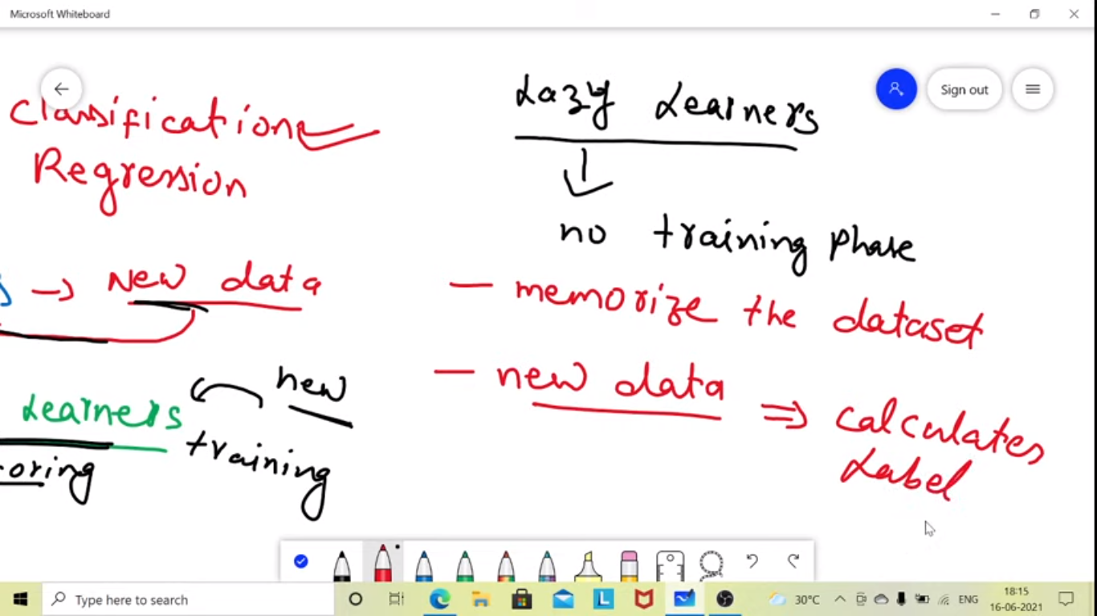

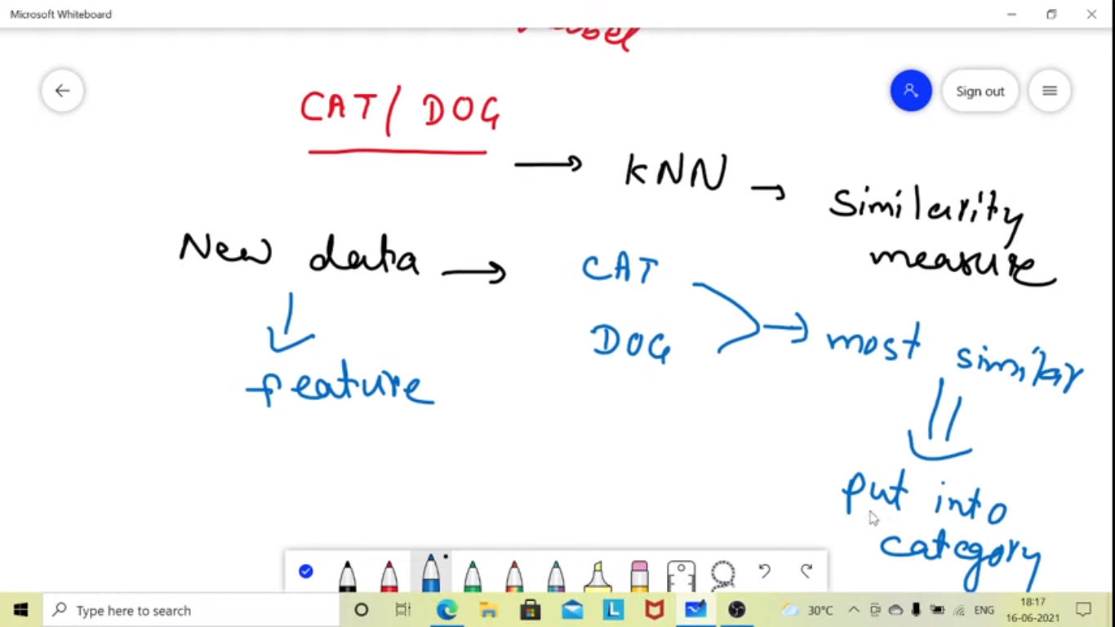

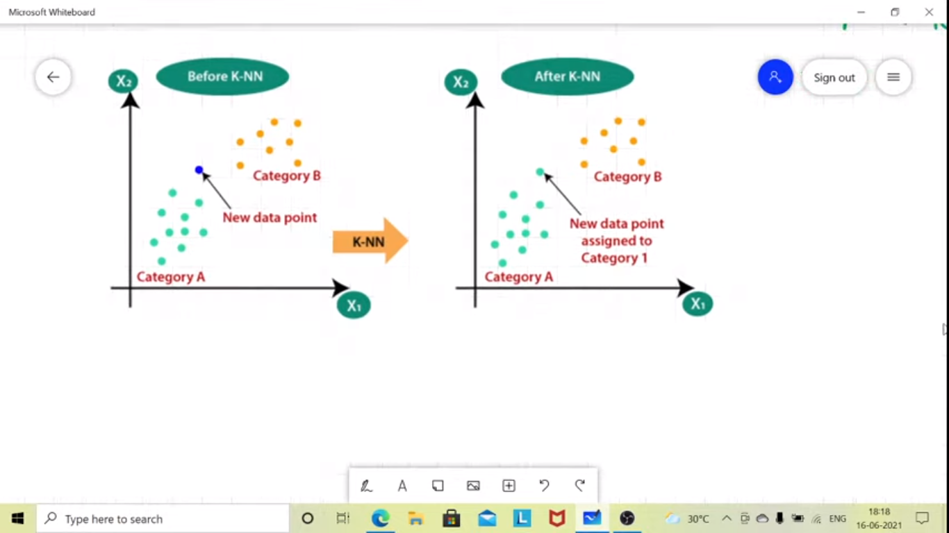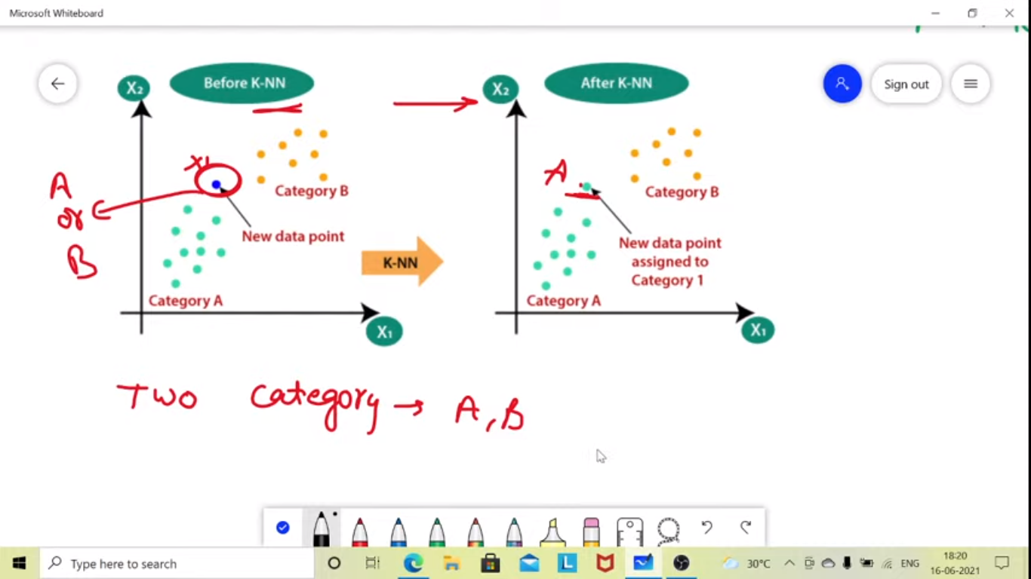

Steps:

1. Find k values – (k- no of neighbours)
2. Find the Euclidian distance from all data points
3. Pick the minum distance points based on k values
4. Then find which point fall in which category
5. Then baased on max no of points in a class will be the predicted values

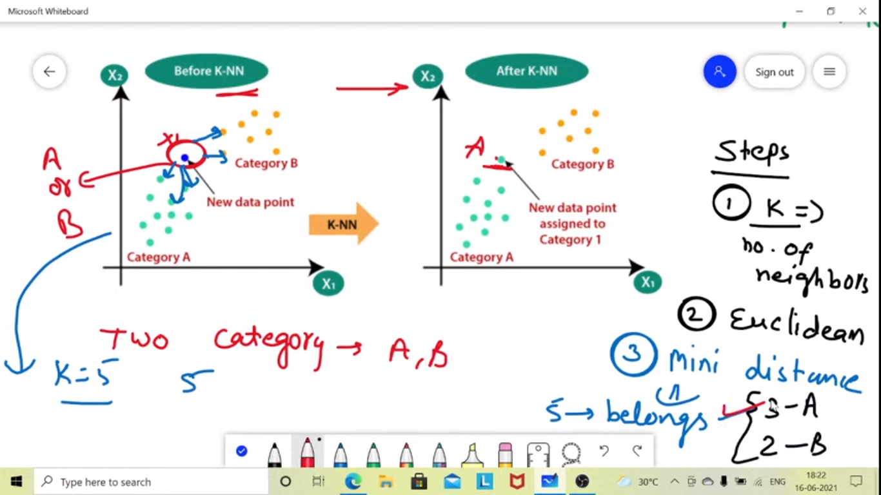

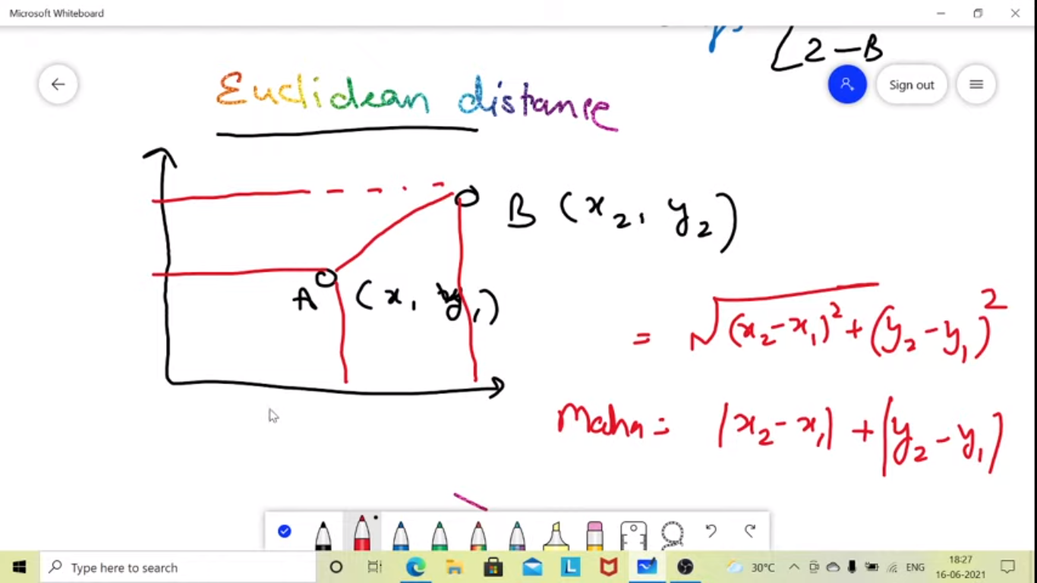

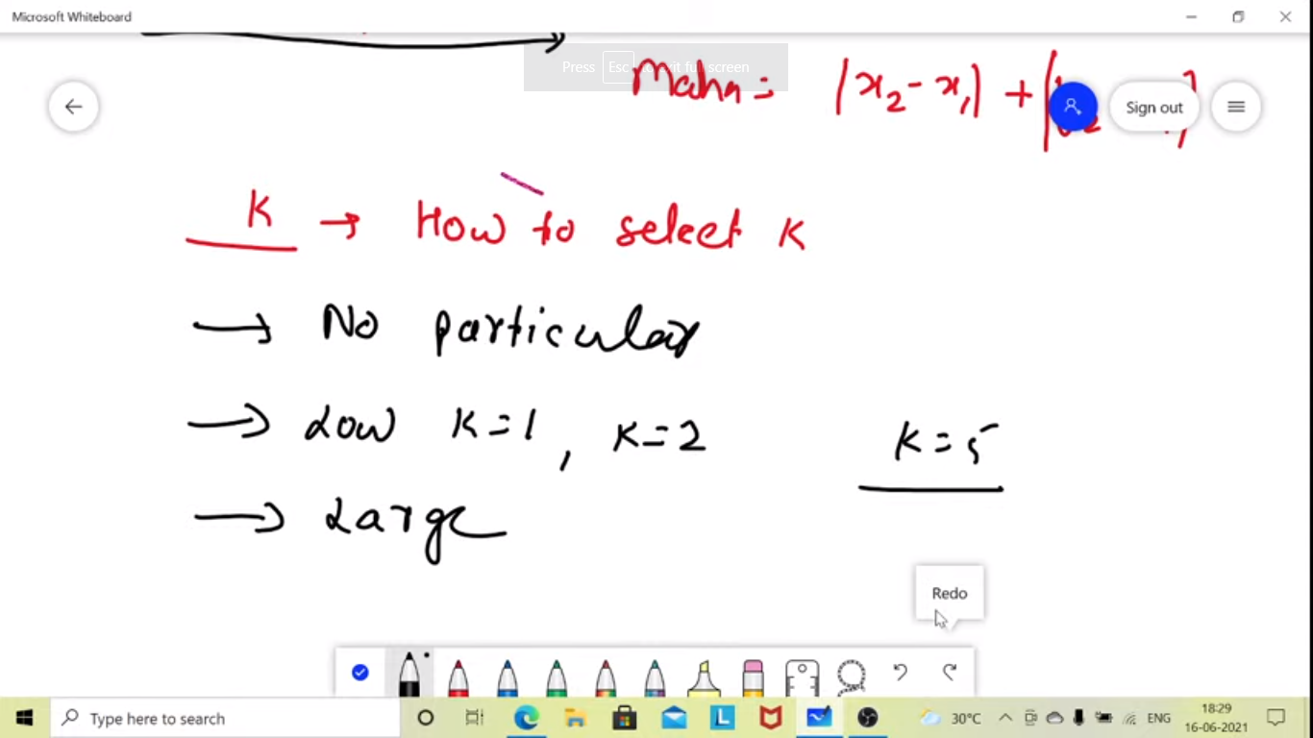

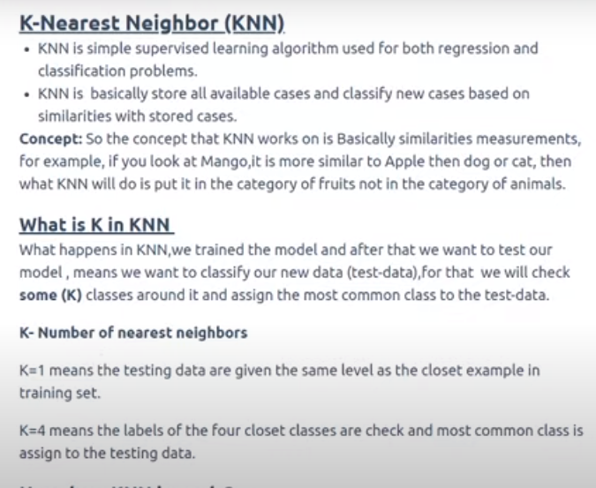

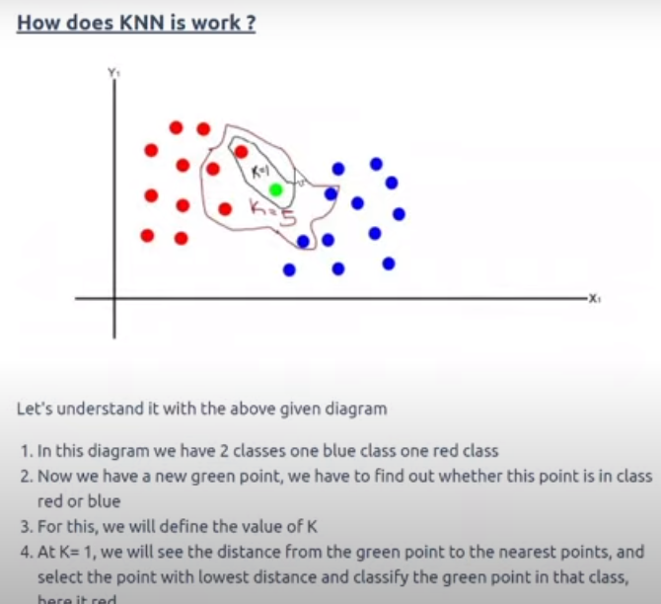

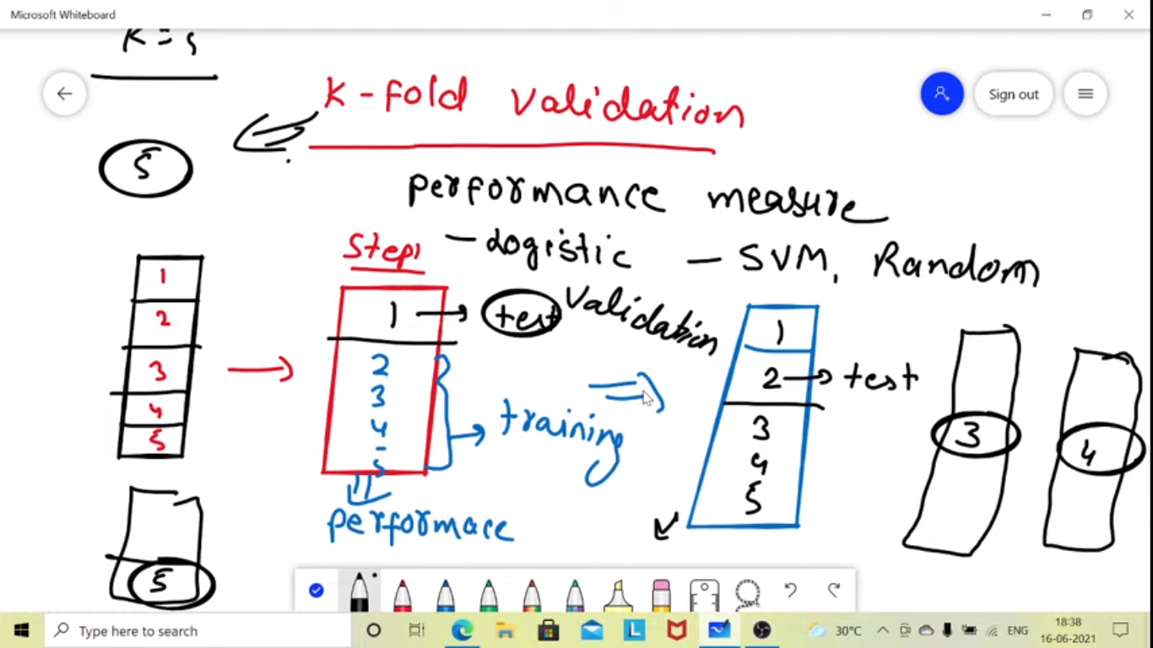

K- Fold – Dividing the data set to 5 in above case and then all the 5 times the test data will be different which will be used for validation and the accuracy will be checked for each.

WEB SCRAPING

Collect data from web sites

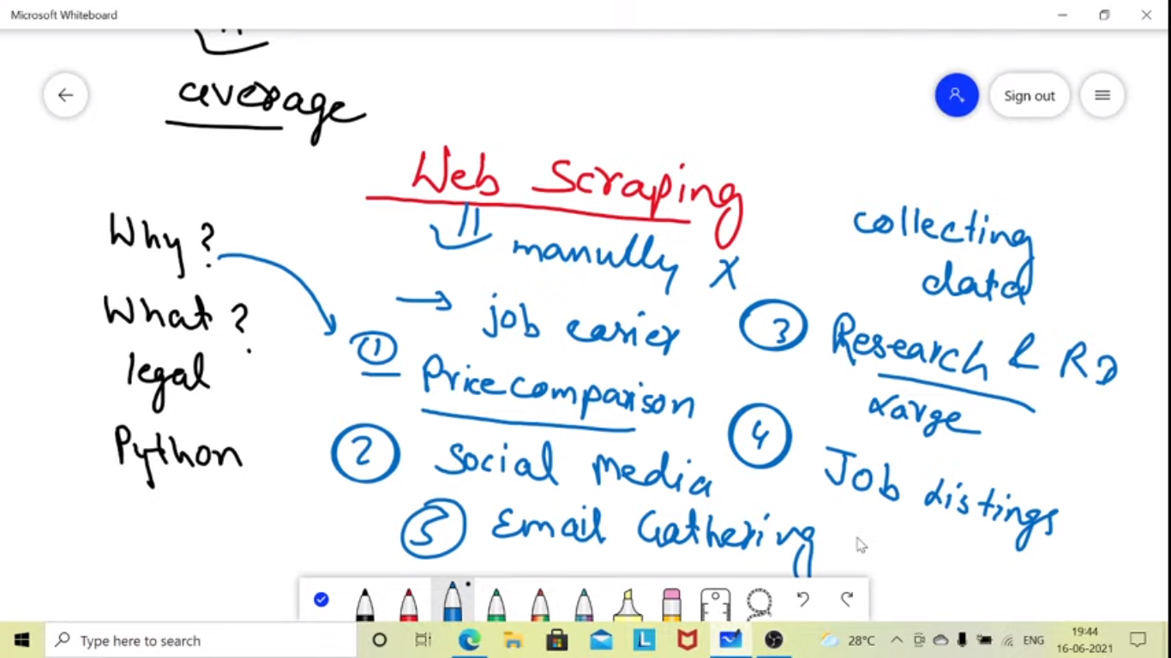

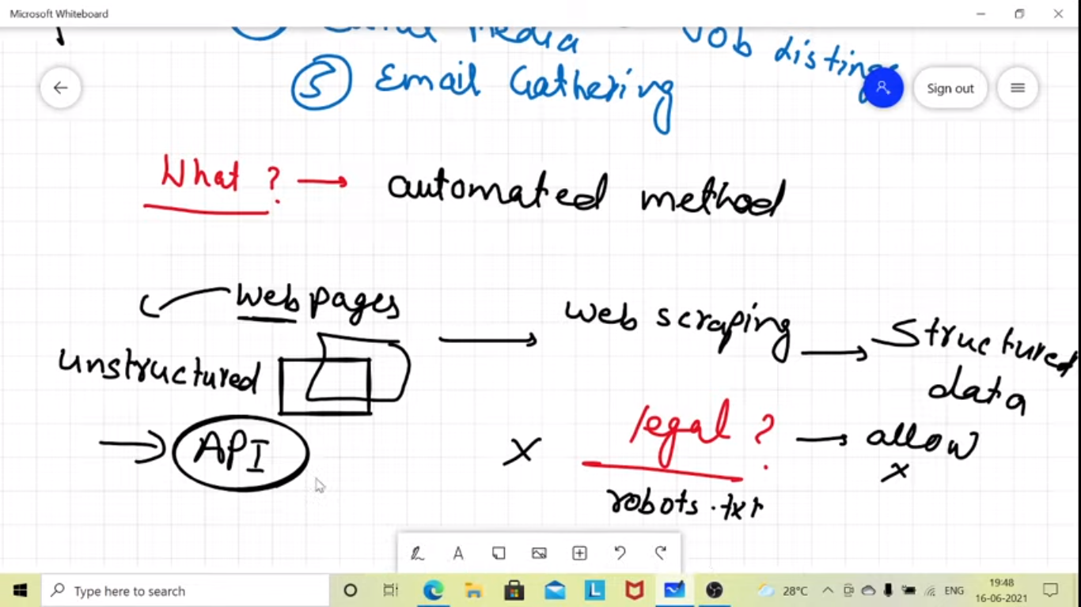

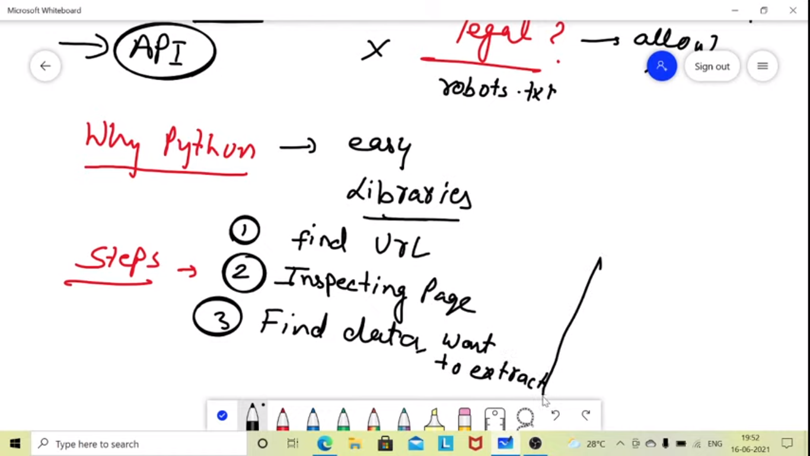

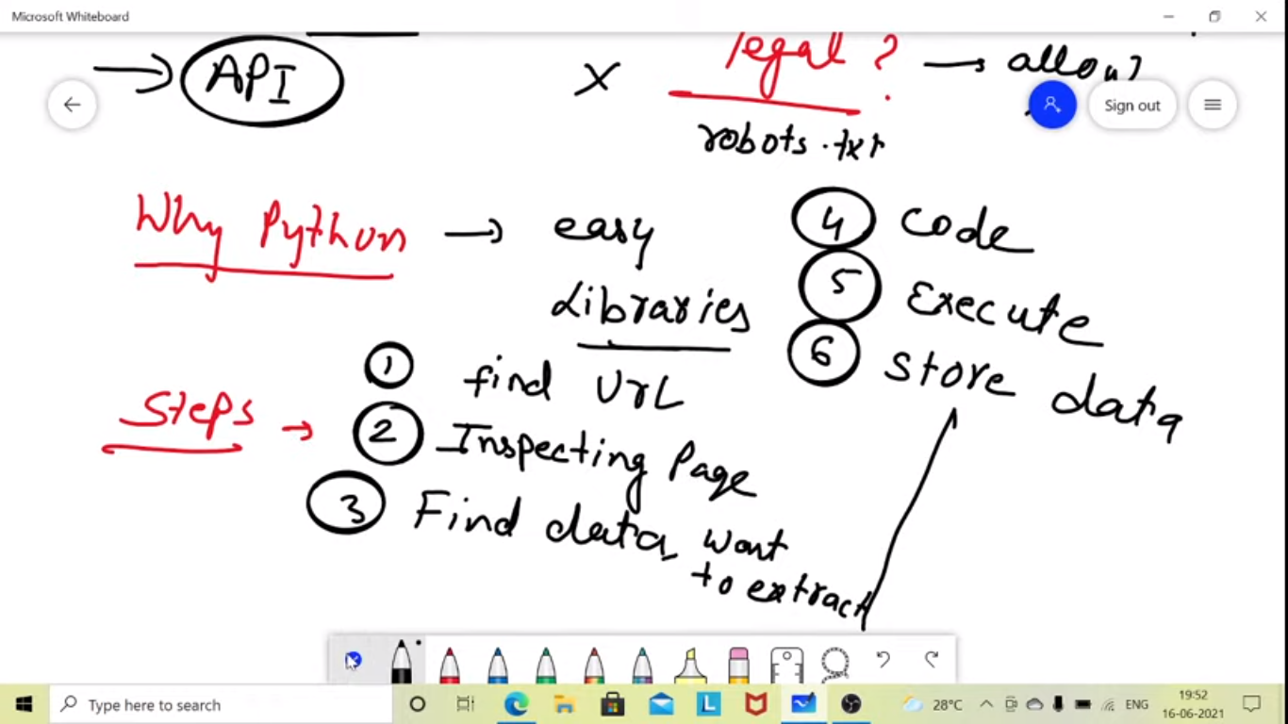

Python lib for web scraping

